# Accessing the Website：

Download the ass2 zip package, unzip the ass2 zip package, open the ass-2 file, then double-click the ASS-2.sln file to open Visual Studio, and then click the green button above to run the web page.

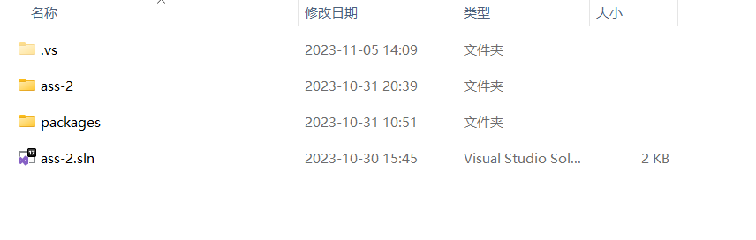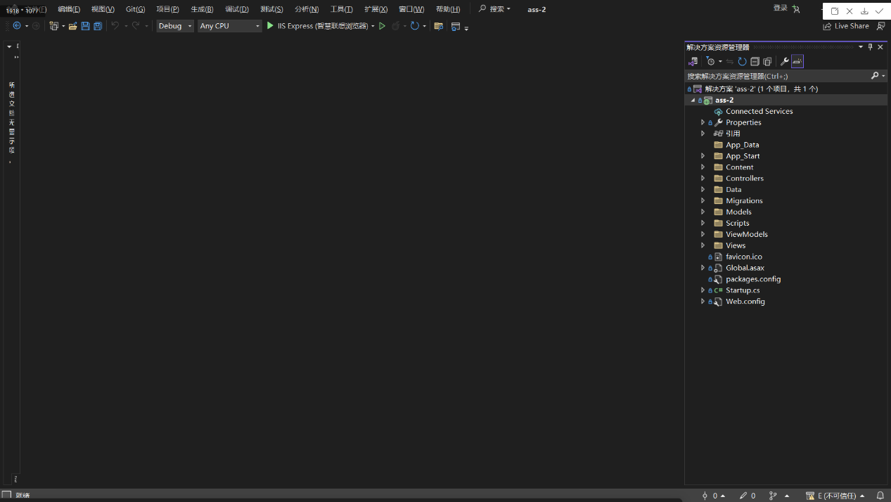

Open visual studio

Double-click the ass-2.sln file

Click the Run button to open the web page

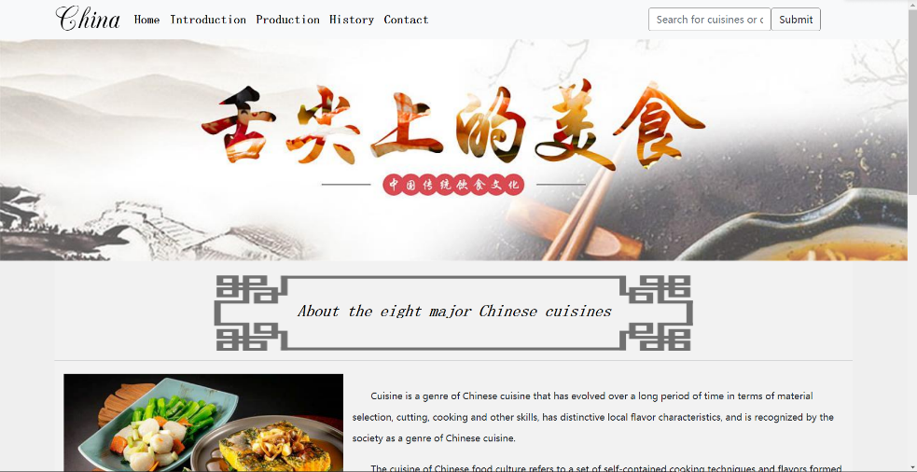Open the homepage as follows:

# Website Layout：

The website is mainly divided into five sections, namely Home, Production, Introduction, History, and Contact.

1. Home page: This page gives a brief introduction to eight major cuisines in China.

2. History page: This page introduces the development history of eight major Chinese cuisines from the Song Dynasty to the present, as well as the characteristics of each period.

3. Production page: This page introduces the taste characteristics, production process, pictures and so on of the eight cuisines

4. Introduction page: This page classifies the dishes provided by this website according to the eight major cuisines, and briefly shows the pictures of the eight cuisines.

5. Contact page: This page provides emails to contact this website, which can provide you with comments about dishes and suggestions on this website.

### Home：

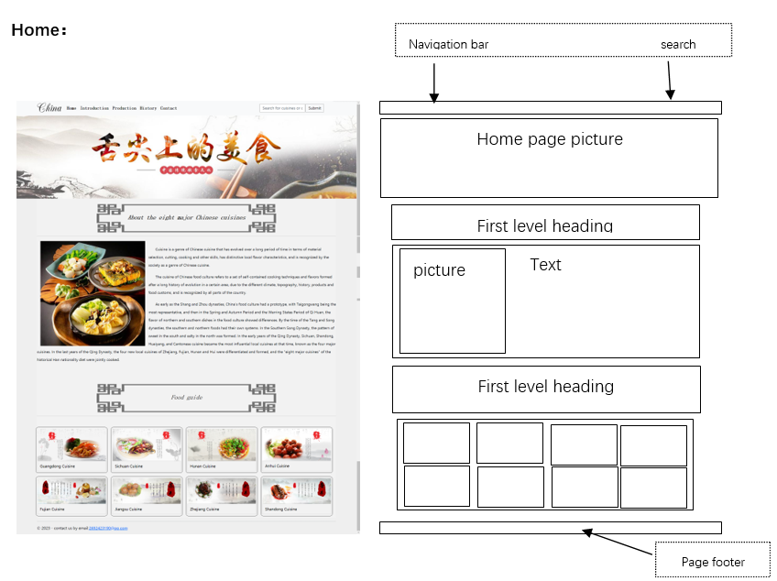

First level heading

### Introduction：

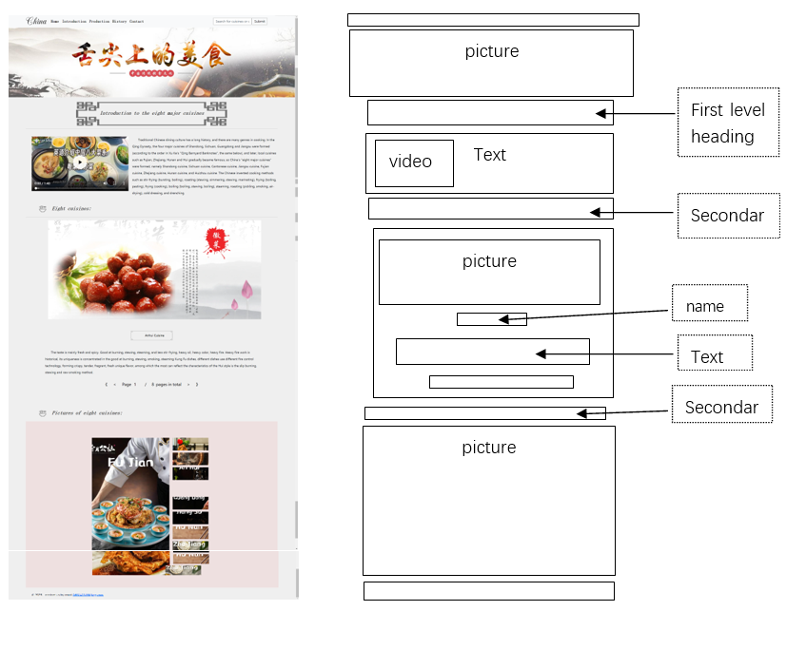

### Production：

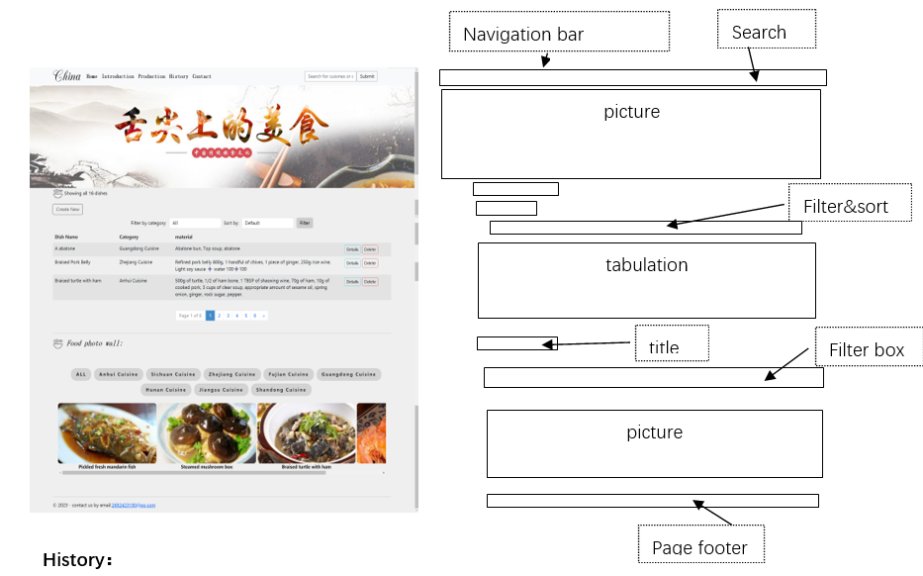

### History：

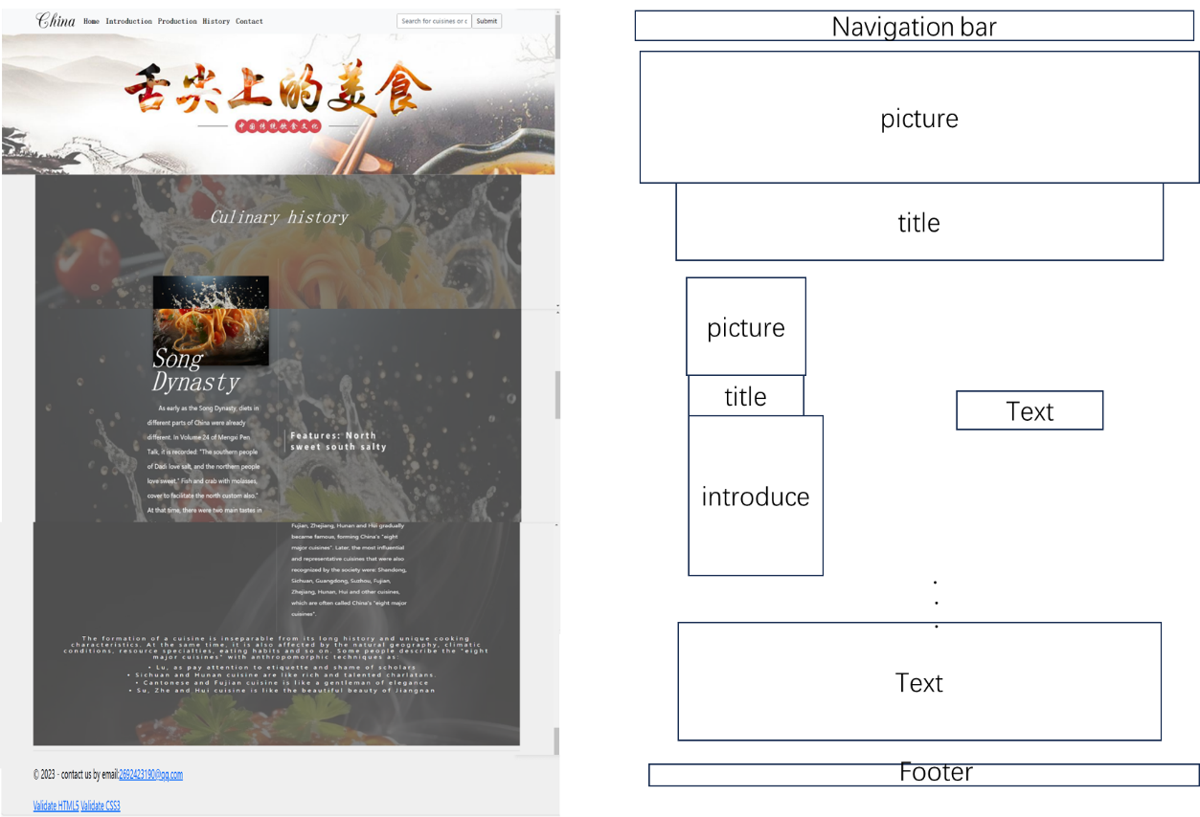

### Contact：

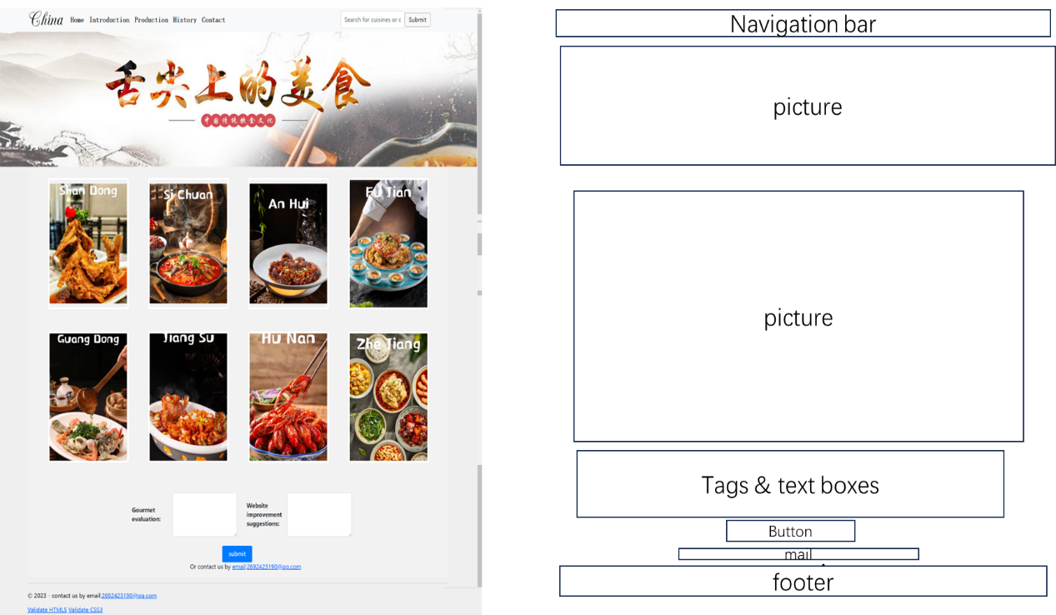

### Details&Delete：

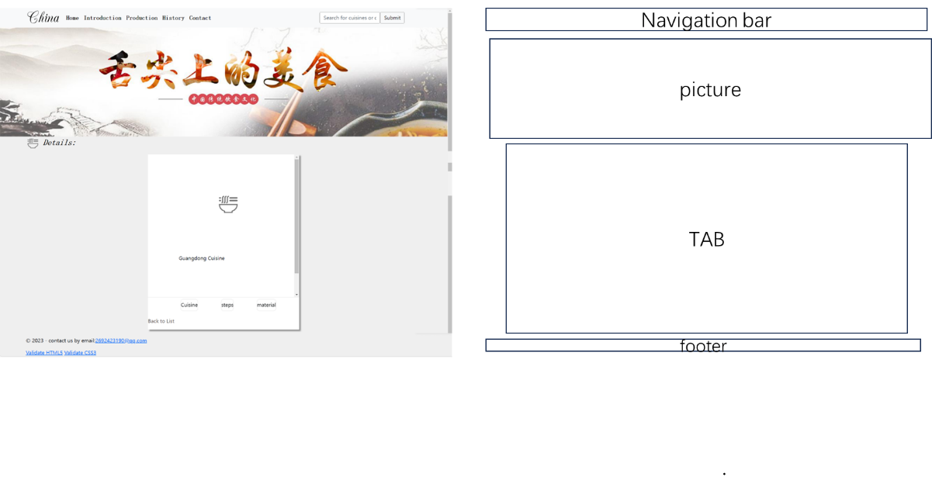

# Utilizing Website Features:

### Home

The function of the Home page is shown in the figure：

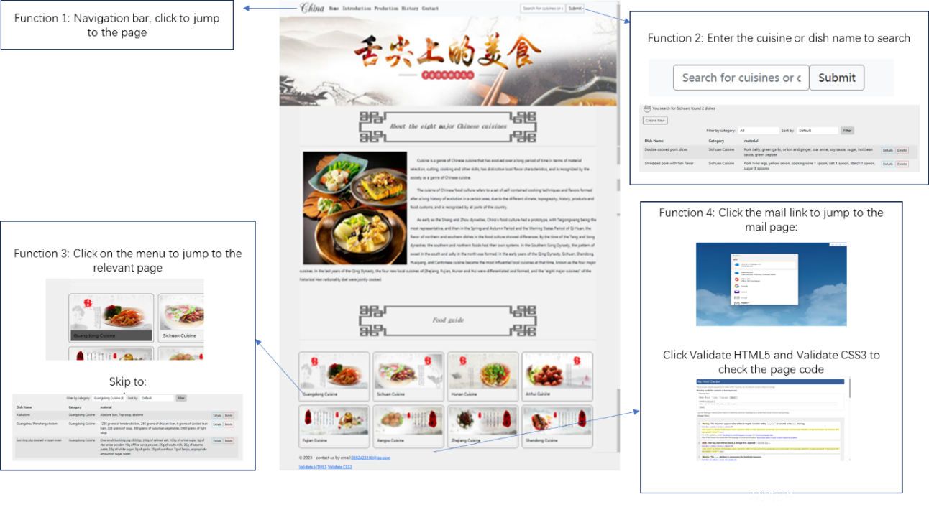

### Introduction

The function of the Introduction page is shown in the figure：

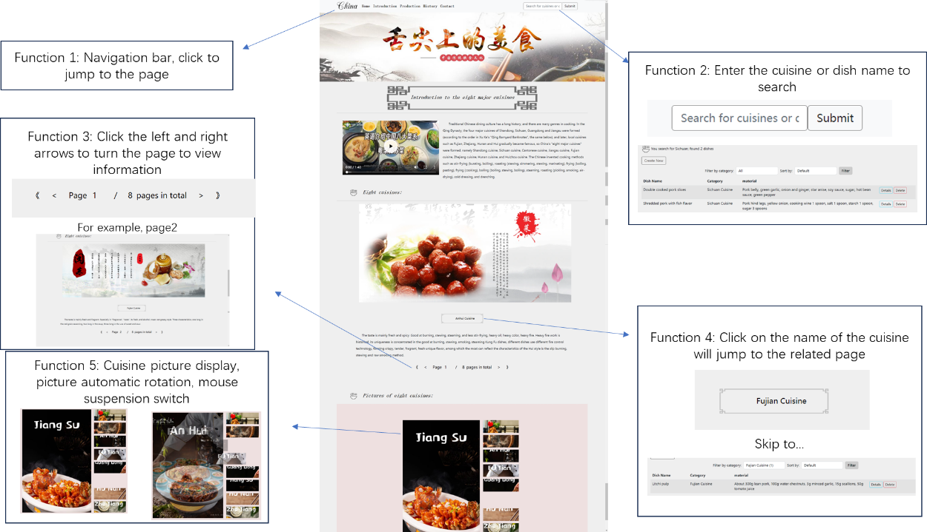

### Production

The function of the Production page is shown in the figure：

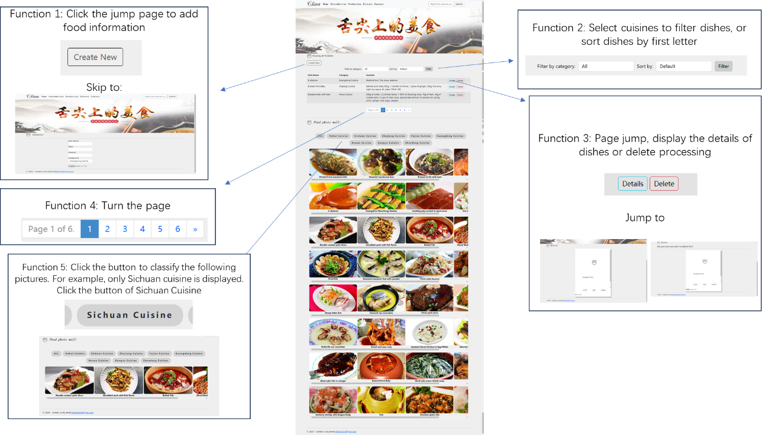

### Contact

The function of the Contact page is shown in the figure：

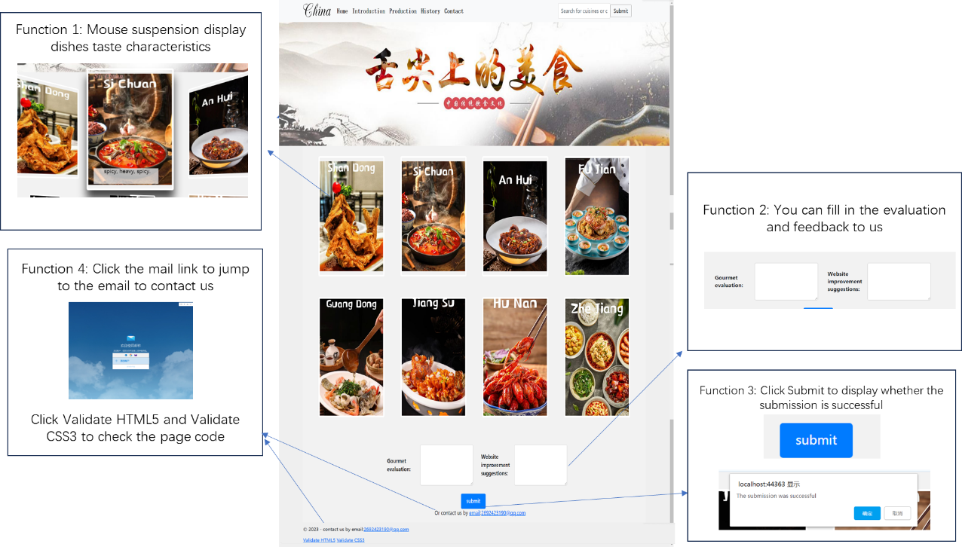

### Details&Delete

The function of the Details&Delete page is shown in the figure：

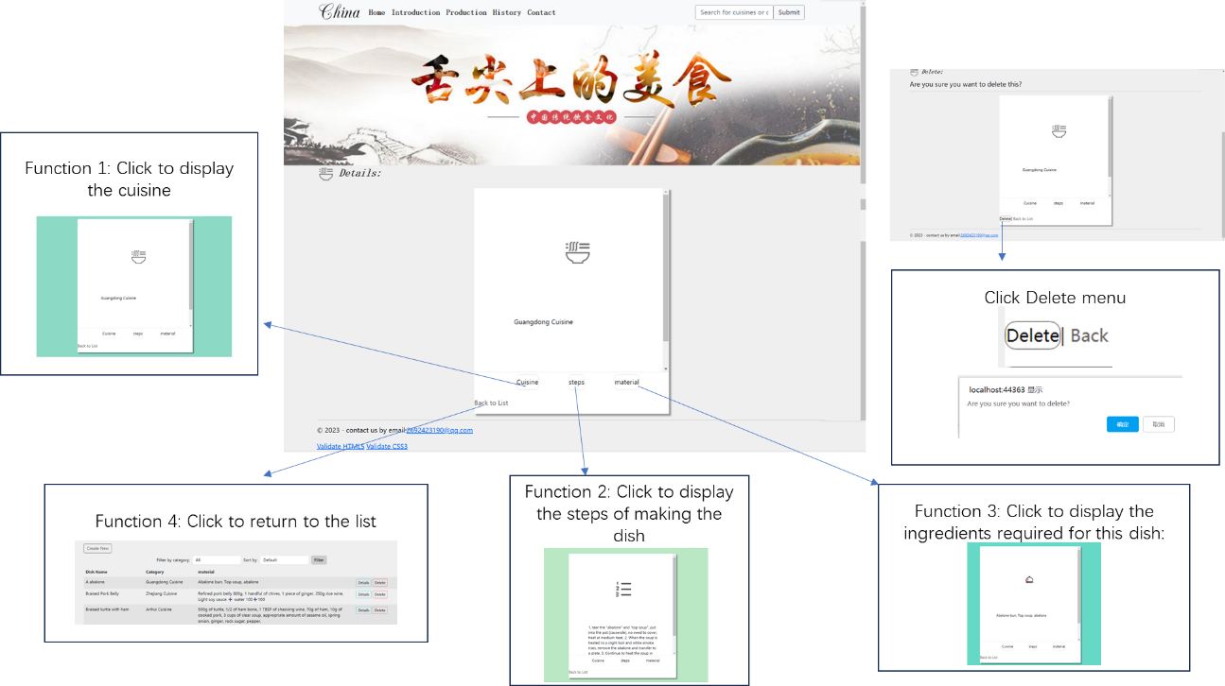

### Create

The function of the Create page is shown in the figure：

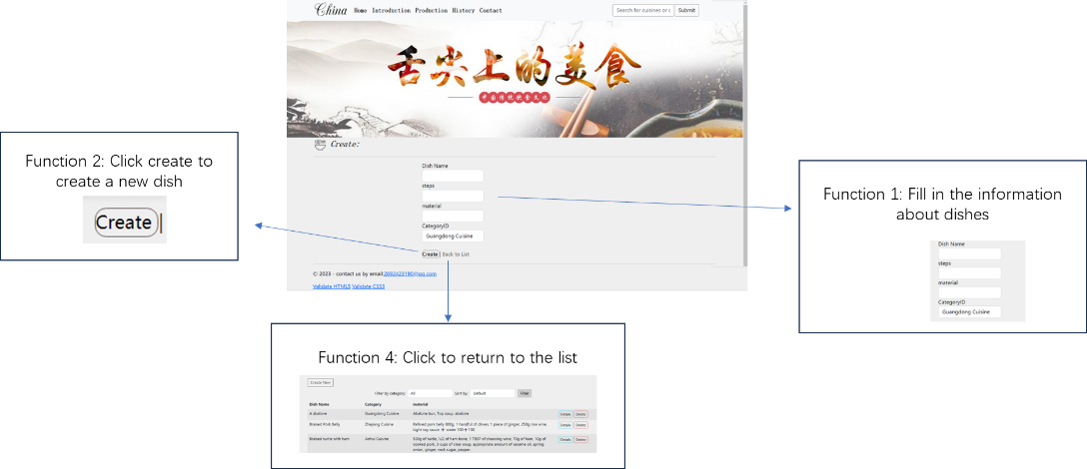

# Technical Demonstrations

## Models:

The two model classes Dish and Category are used to describe the properties and relationships of different entities and are used in the Entity Framework to map the structure of database tables. Here's an analysis of both models:

### Dish model：

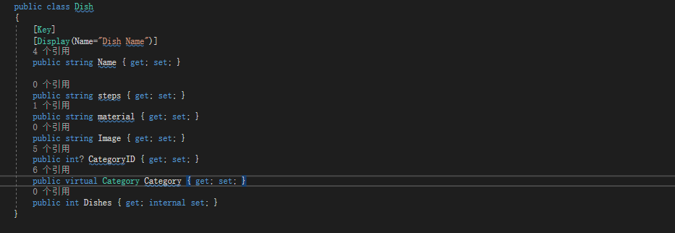

* Name: Represents the name of the dish and is the primary key for this entity, uniquely identifying each dish.
* steps: Contains instructions on how to prepare a dish.
* material: Stores the ingredients or descriptions of the ingredients needed to make a dish.
* Image: indicates the image path or file name of the dish.
* CategoryID: Indicates the foreign key that represents the category associated with a dish.
* Category: Indicates the association between dishes and categories. This is a navigation property that can be used to get the category objects associated with the dish.
* Dishes: An attribute with an internal set, usually not publicly exposed to external code.

In the Dish model, there is a foreign key property called CategoryID that associates each dish with a category. In addition, there is a navigation attribute Category, which is used to get the category objects associated with the dish. This creates a many-to-one relationship where multiple dishes can belong to the same category, but a dish can only belong to one category.

### Category model：

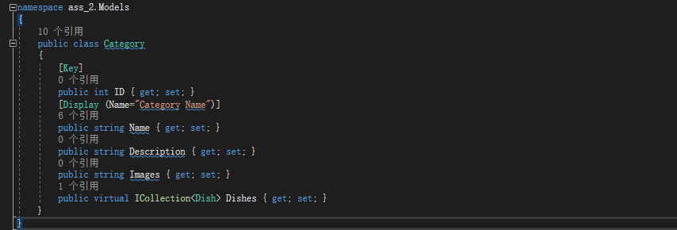

* ID: The unique identifier that represents the class and is the primary key for that entity.
* Name: indicates the category name and can be used to describe the category to which the dish belongs.
* Description: Contains the description of the class.
* Images: Stores image information related to classification.
* Dishes: Indicates the relationship between categories and dishes. This is a collection property that indicates that a category can contain multiple items.

In the Category model, there is a collection attribute Dishes, which indicates that a category can contain multiple dishes. This establishes a one-to-many relationship, i.e. a category can contain multiple dishes, but a dish can only belong to one category.

Seed data is often used to provide some initial value for the entity objects in these model classes. You can use the seed data method to add initial data. In Entity Framework Core, the HasData method is typically used to add seed data during database migration, and finally, the database context needs to be associated with the seed data in the startup file of the application. You can use the migration tool provided by Entity Framework Core for database initialization.

## CSS:

### 1、Page color

Mainly grey: #efefef, #f2f2f2, #555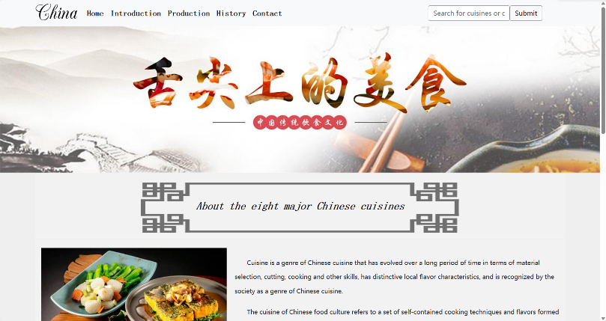

### 2、Navigation bar

Define a font "Champagne", "China" uses this font, other elements of the navigation bar set the font size to 20px, the font style is serif, the font is bold, the mouse hovers to change color, and the color gradient effect, etc., the search box is set with a border, rounded corners, and the submit button mouse hover changes color (see the code for details, the effect is as follows)

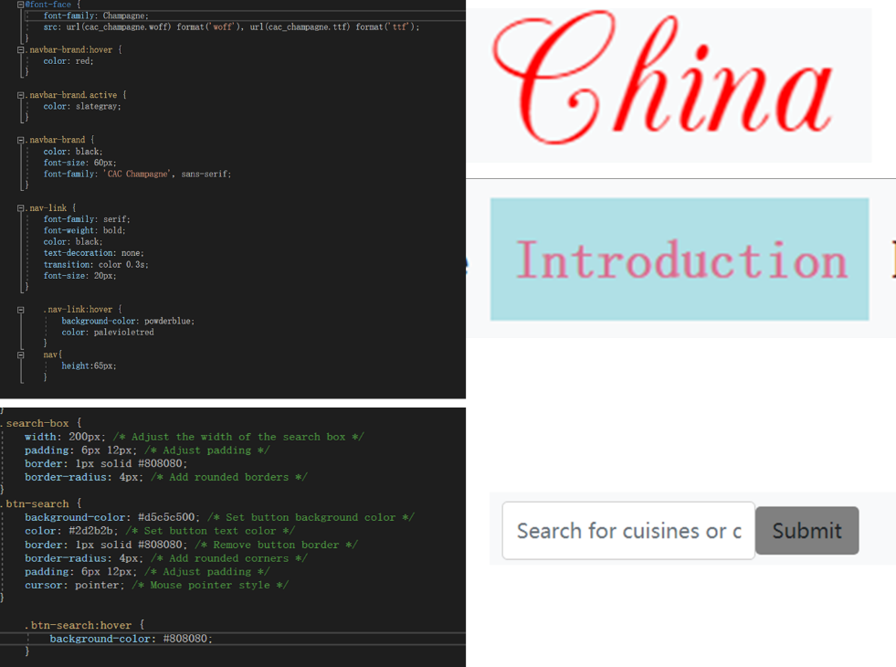

### 3、title：

**The first type of heading:** .major class element will have a specified background image, the background image is centered inside the element, does not repeat, the size occupies 60% of the width and 100% of the height, the text content is centered, with 40 pixels of padding and 30 pixels of text line height. The <h2> header element will have the specified font serif, italic style, bold, font size 26px, color black, and text line height 35px.

**The second type of heading：** flavors class element has the specified font serif, bold, 26px font size, black color, and a small icon inserted in front of the title.

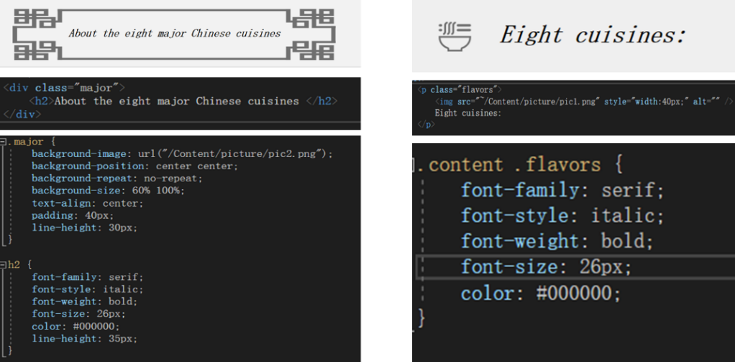

### 4、Text introduction at the beginning of the page：

Home page: Picture left, text right; Introduction page: Video left, text right. Set the images and videos to float: left and set them to the appropriate size (30% image width, 500px video width) and 20px margin from the text.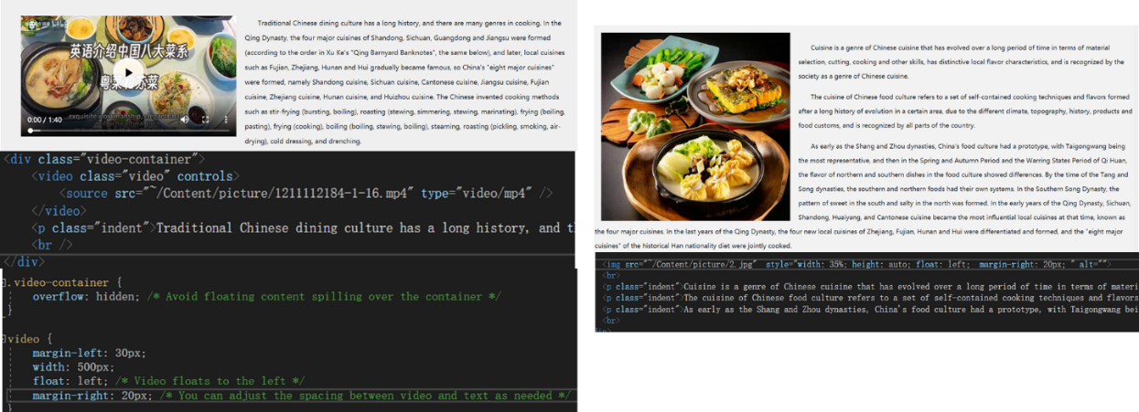

### 5、Picture link：

* border: 1px solid #ccc;：Set the border of the linked element to 1 pixel wide gray
* color: black !important;：Set the link text color to black and use! It is important to ensure that this color takes precedence over the default style.
* display: block;：Sets the display property of the linked element to a block-level element so that it occupies the entire available width.
* font-family: "Bahnschrift SemiLight": Specifies that the font for the linked text is "Bahnschrift SemiLight".
* background-color: #555;：When hovering over the link, set the background color of the link to dark gray (#555).

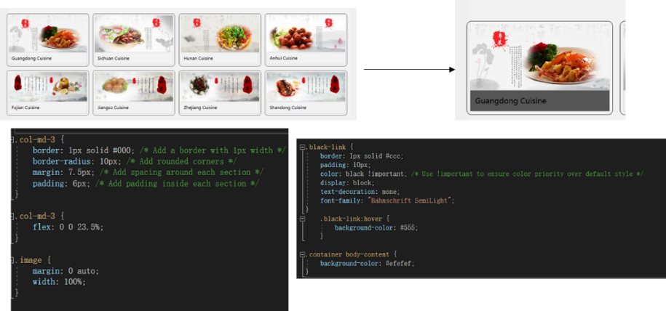

### 6、Button：

**The first:** set the flex layout, set the button background, button border rounded corner 20px, font bold, mouse suspension color, Flex-wrap: wrap: if the li elements exceed the width of the container, allow them to wrap; margin: 0 10px; : Reduce the left and right margins of the li element when hovering, so that they are closer to etc.

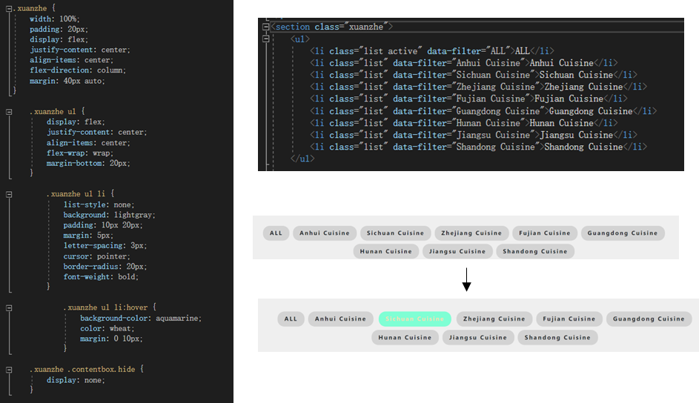

**The second**: set the background transparent, with the corresponding color of the border, mouse suspension color change.

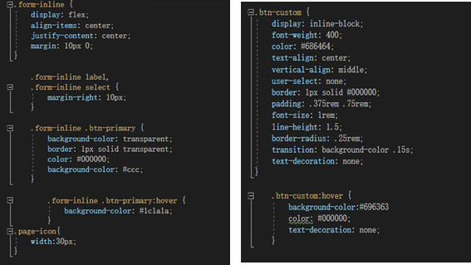

### 7、Picture display：

**The first card switching mode:** set the background color to light purple, transparency to 60%, use flex layout, add 0.4 seconds of transition effect, so that the background image is displayed in the way of covering the entire element, Flex-direction: column: vertical layout, so that the internal content is arranged vertically; justify-content: space-between: Adds vertical spacing, etc., between the content in a column. Used to create a flexible layout, including background colors, Flex layout, transition effects, and hover effects to make web elements look more interactive and attractive, see the css code below for details.

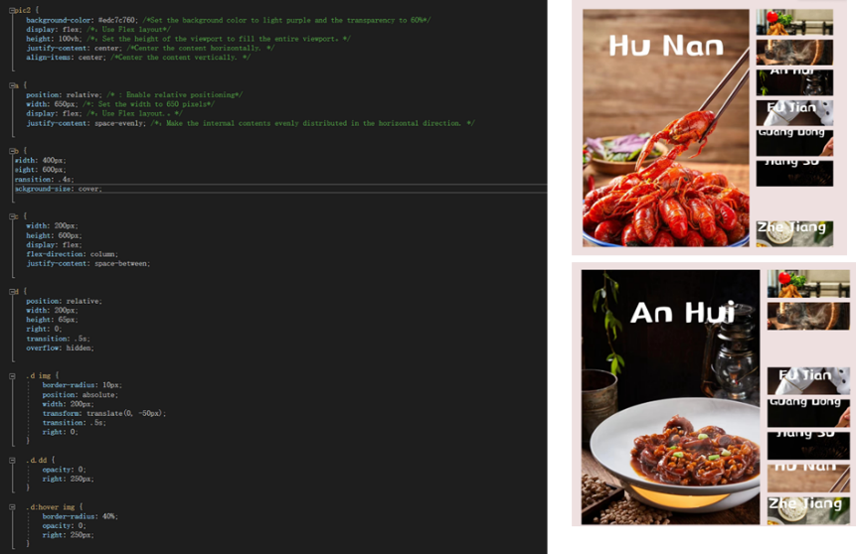

**The second type of scroll bar:** display: inline-block: sets elements as inline block-level elements, so that multiple.item elements are in the same line and the width and height can be set; overflow: auto: Displays a scroll bar for scrolling when content overflows the container; clear: left: Clear the left floating element to ensure that the figure element is not affected by other left floating elements, etc., as shown in the following code. Together, these rules create a style for the image and its description, where the image is arranged horizontally, the image description is displayed below the image and centered, the image has a rounded border, and the image and description can be rolled horizontally within a narrow container.

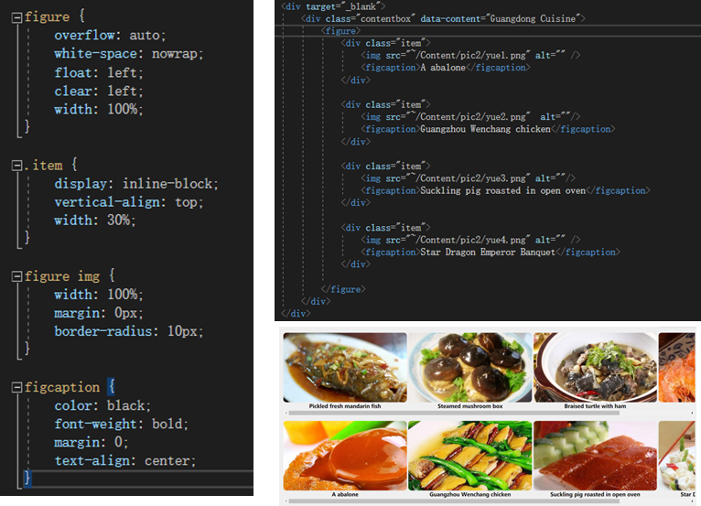

**Third 3D effect:** When the mouse hovers over the.shell container, all.box elements are rotated 40 degrees on the Y-axis, creating the flip effect of the card. When a.box card is hovered over, it scales 1.25 times to get a shadow and become the topmost element. The.box element before the card hovering along the container will rotate -40 degrees on the Y-axis, creating an inverted effect. .box.Content h2 and.box.Content p have the effect of appearing gradually from above and below, changing their position and color.

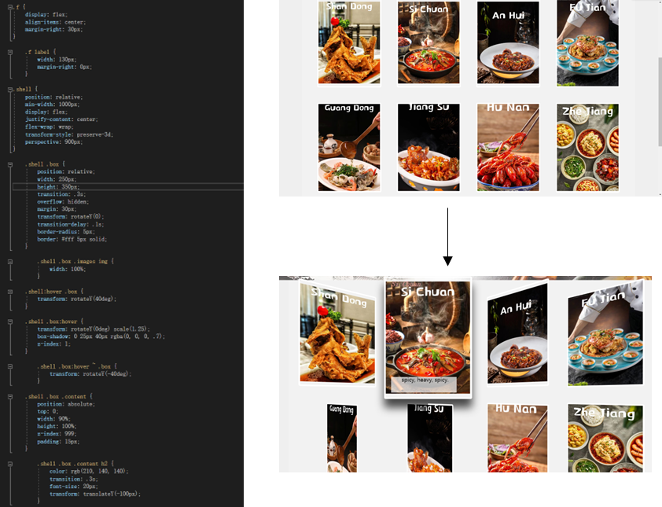

### **8、Paging table**：

Adjacent rows alternate colors for easy differentiation, and use the Flex layout model so that elements containing the class are arranged horizontally. The PagedList.css file is displayed because of too much code

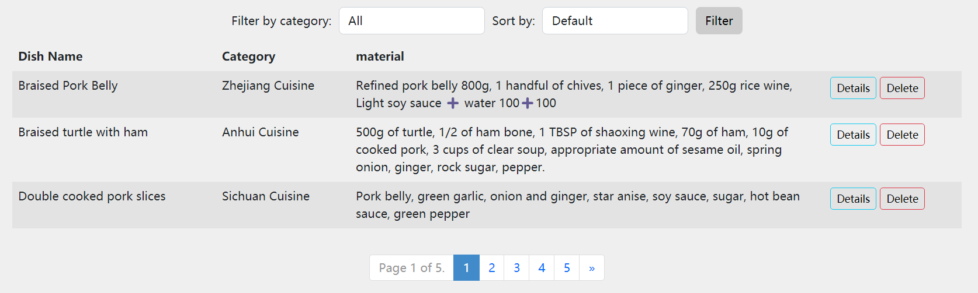

## JS:

### 1、The effect of a wheel cast：

1. First of all, through the document. QuerySelector and document getElementsByClassName access the HTML element in the object, b represent to the left of the big picture elements, d on behalf of the right of the element list picture.
2. The variables time and index are declared. time is used to store the rotation timer, and index is used to track the index of the currently displayed picture.
3. Defines a function called a that resets the style of the small graph elements by setting their className to "d" in order to uncheck the small graph elements.
4. Defines a function called aa that marks a small graph element with a specified index as selected. Inside the function, the a function is first called to reset all small graph elements, and then the className of the small graph element for a particular index is set to "d dd", thus applying the style of the selected state.
5. A function called ts is defined to start a timer for the carousel. In the timer's callback function, first call the aa function to select the next picture, and then increment index to switch to the next picture.
6. Go through all the small graph elements through a for loop, and bind the onmousemove event handler for each small graph element.
7. Finally, call the ts function again to restart the wheel timer.
8. Finally, call the ts function to start the wheel cast.

This code to achieve a carousel effect, the user can hover on the small picture to switch the big picture, can also automatically carousel to switch the big picture.

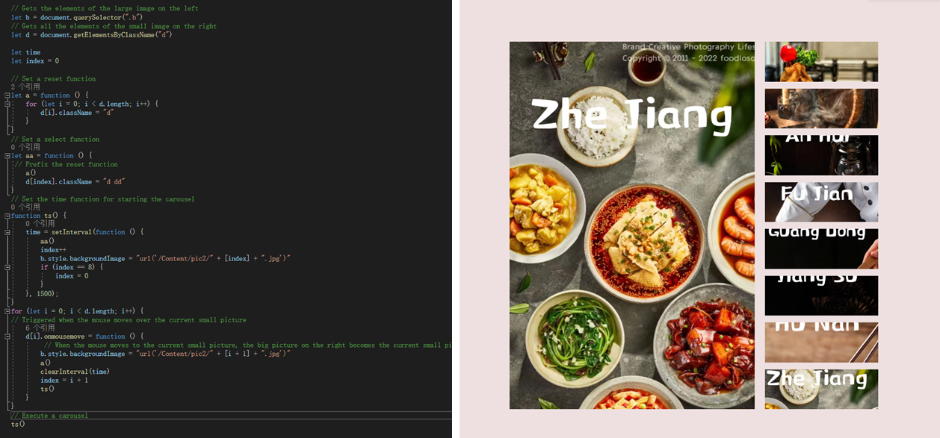

### 2、Filtering function

Allows users to control which content boxes are displayed by clicking on different list items. When a user clicks on a list item, the selected filter shows or hides the corresponding content box. Its key features include:

1. Get the elements in the page with the class names 'list' and 'contentbox' for subsequent operations.

2. Add a click event handler for each list item in response to the user's click action.

3. When the user clicks on the list item, the script cancels the activation status of the other list items, and then marks the currently clicked list item as active.

4. Show or hide the matching content box based on the selected filter criteria. If the filter is 'ALL', all content boxes are displayed, otherwise only the content boxes that match the filter are displayed, and the other content boxes are hidden.

The code is explained in the following code comments

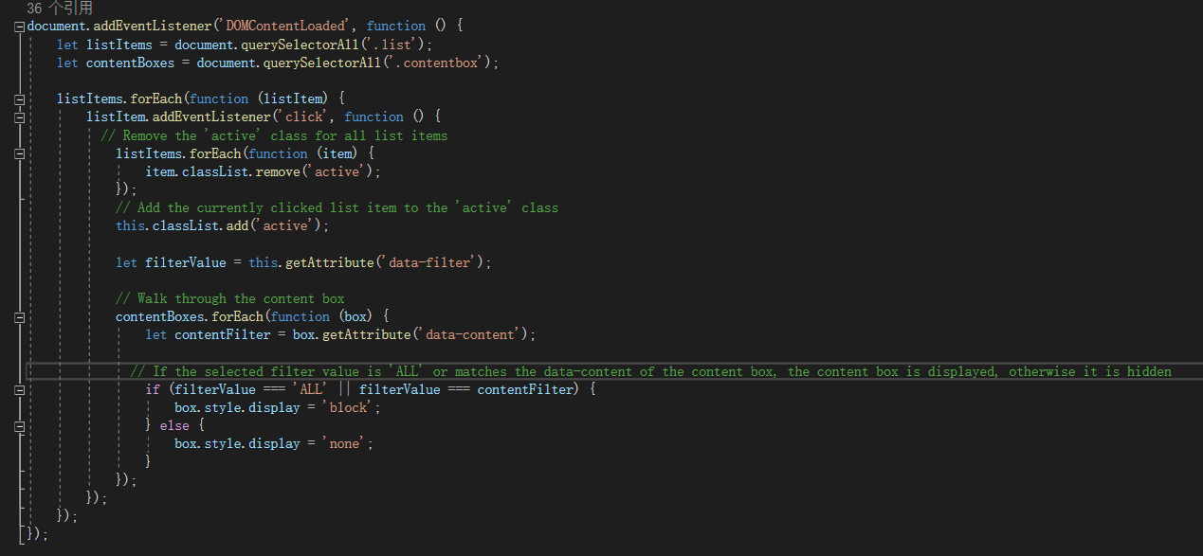

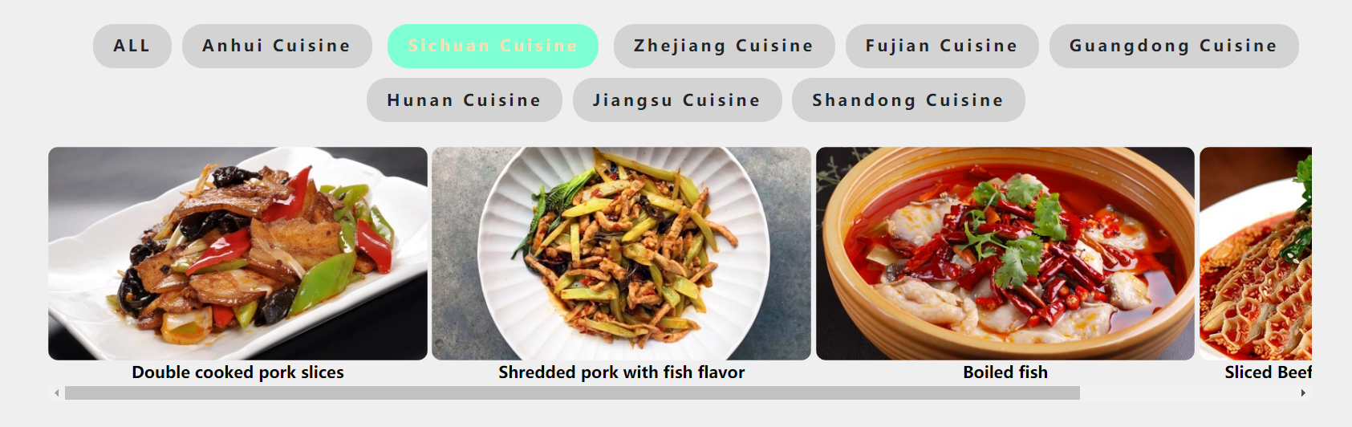

### 3、Page switching and theme switching：

This code implements an interactive feature that when the user clicks on an element with the class name "list", it will switch the position of the main content area and change the background color of the page depending on the element clicked. This is often used to create user interfaces with different content page transitions and theme switches.

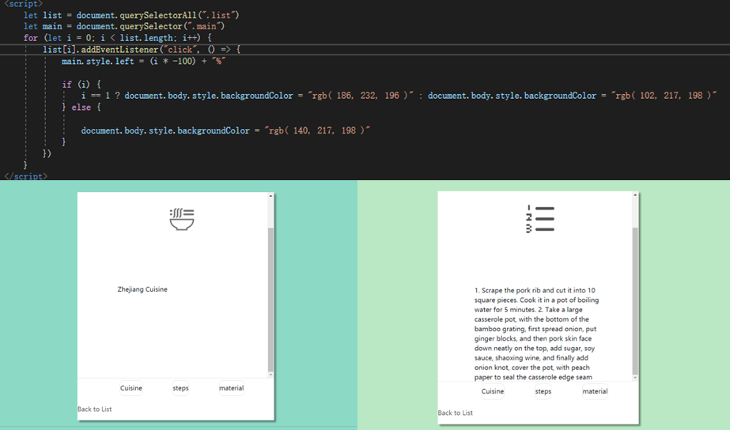

### 4、Prompt box：

In the function, first use the confirm function to display a confirmation dialog box with a message: "Are you sure you want to delete?" . The confirm function returns a Boolean value representing the user's response. isConfirmed will be set to true if the user clicks the Confirm button, otherwise it will be set to false. Next, the code uses conditional statements to check the value of isConfirmed. If isConfirmed is true, the user clicked the confirm button, and the code in the conditional statement block is executed. Otherwise, if the user clicks the cancel button, the code in the else part of the conditional block executes. If the user clicks the Confirm button (isConfirmed as true), the alert function displays a dialog box with the message "Item deleted!" ; If the user clicks the cancel button (isConfirmed to false), the alert function displays a dialog box with the message "Deletion canceled."

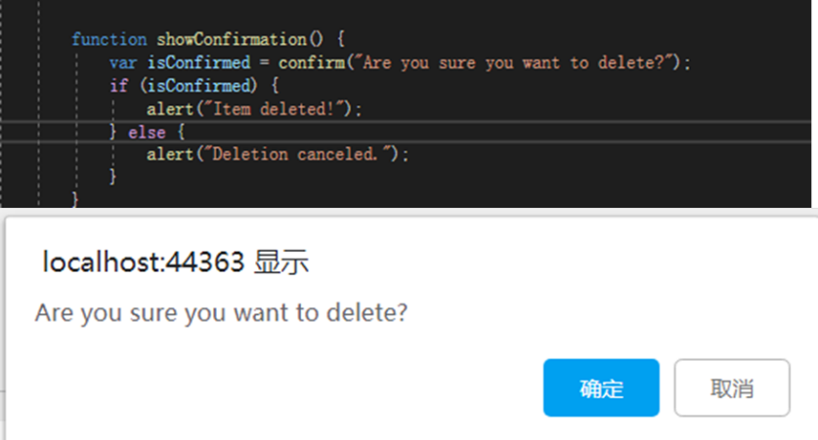

### Timeline

First, introduce the jQuery library and define the jQuery plug-in. Initially, add an active status class to the first timeline item, and set the background map to the image of the first item, then set the page listener, when the page scrolls, trigger this event, update the timeline status according to the scroll position:

If the scroll position is more than half of the second-to-last item, update the image of the last item in the background map to set the last item to active. Otherwise, update the background map and activity status based on the scroll position.

Finally, the plug-in is applied in HTML, and the detailed code explanation is shown in the following code comment

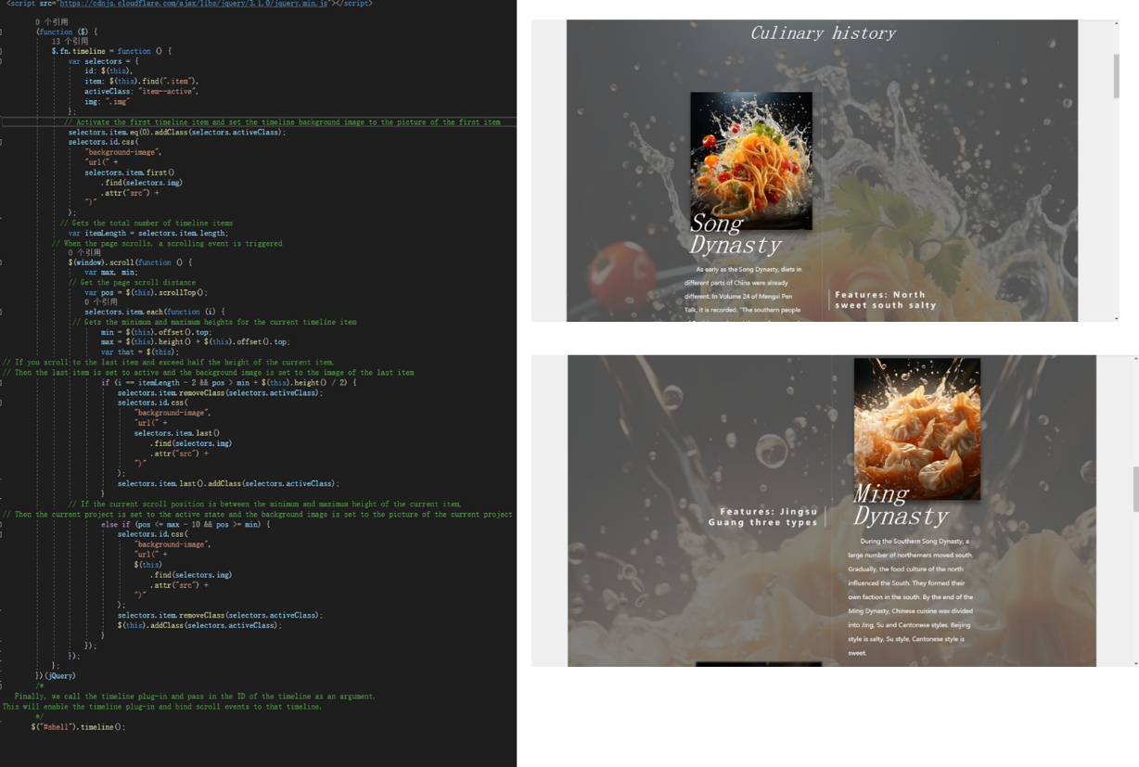

# Feature Implementation:

We implemented these functions in the Index in DishesController.cs. Here is an example of a page that implements the functionality.

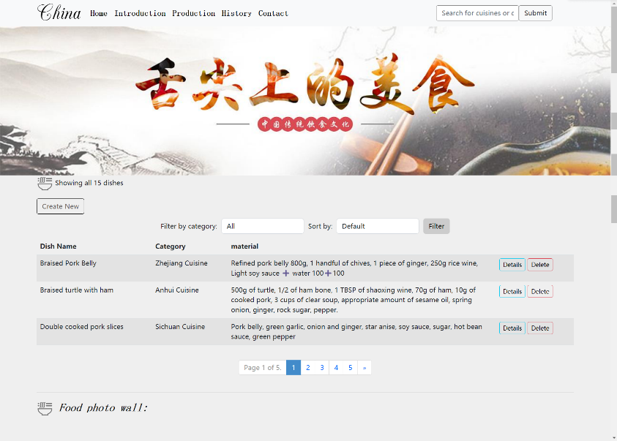

### search

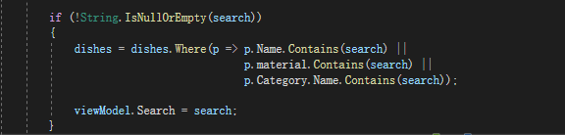

This code shows how to implement basic search functionality in your application. This feature allows the user to enter a Search keyword, then filter out products that contain the search keyword (name, ingredients, category) by using the Where method, and finally save the search keyword to the search property of the Viewmodel for subsequent display or processing.

### Count the number of products by category

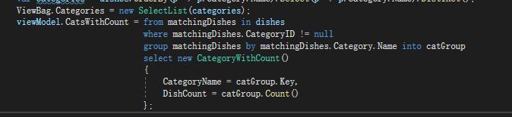

This code mainly processes the dishes and generates part of a viewModel.

Dishes are manipulated via LINQ queries and assigned to the CatsWithCount property of the viewmodel. "Group matchingDishes by matchingDishes. Category. The Name into catGroup" this one line of code has carried on the grouping operation. It groups dishes by their category names and stores the results in a catGroup.

So, the main function of this code is to extract the names of the categories from the list of dishes and count the number of dishes in each Category. Finally, this information is stored in the CatsWithCount property of the viewmodel to display the categories and their corresponding number of dishes in the view.

### filter

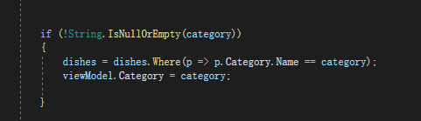

This code is mainly used to filter dishes based on the selected category and update the Category property of the viewModel. If the user selects a specific category (via the category variable), the dishes are filtered to show only those that belong to that category, and the selected category names are stored in the view model for display in the view. If category is empty or null, it means that the user has not selected a specific category, and no filtering will be performed.

### sort

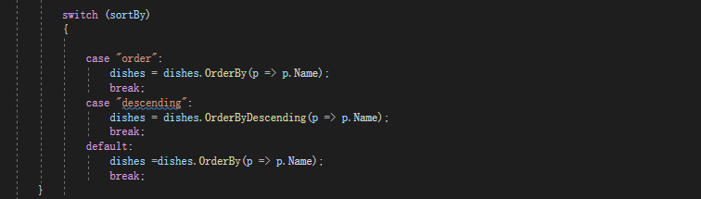

This code is a controller action that sorts the list of dishes according to the sort method selected by the user, and provides the user with two sorting options (ascending and descending)

Build Sort Options:

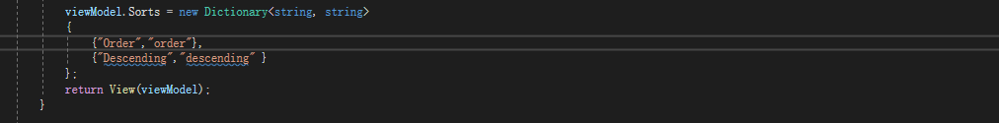

Creates a dictionary object that stores the sort name and corresponding sort parameters to generate sort options in the view. The Order" and "Descending" key-value pairs indicate the sort that the user can choose. Order" corresponds to an ascending sort and "Descending" corresponds to a descending sort.

### paging

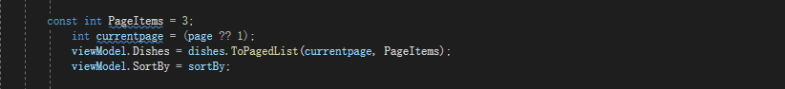

Defines the number of products to display per page, and defaults to page 1 if no page number parameter is passed in. The sorted query results are then paginated using the ToPagedList method and stored in the Products property of the viewmodel. The main function of this code is to paginate the menu list so that the user can select the page numbers to view and store the sorting method for the corresponding display and sorting operations in the Web application.

### API

A JS implementation was written to detect the code, and the detection link was placed in the footer of the page.

